Academic Task Number: CA-2 (Test-1) SET-A Course code: ECE-249 Section: K22EN
Date of allotment: Course title: BEEE Roll No.
Date of submission: Maximum Marks: 30 Reg. No.
Academic Task Type: Subjective
Q. No. | Question Statement | Course Outcome | Bloom’s level | Marks
Q1 | A 16μF capacitor is connected across 200V, 50 Hz source. Calculate the reactance offered by the capacitor at fundamental frequency, maximum current in the circuit, the average and r.m.s. value of the current drawn by the capacitor. | CO2 | L3: Create | 5
Q2 | An AC voltage is mathematically expressed as v=165 sin (188.4 t + П/3) volts. Find it’s effective value, average value, frequency and periodic time. | CO2 | L3: Apply | 5
Q3 | Convert the following when R3=25 ohm and Ra=40 ohm. All the resistances are in ohms.  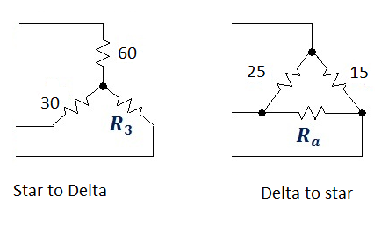 | CO1 | L1: Apply | 5
Q4 | a) Explain current to voltage transformation?  b) By using source transformations and equivalent resistances simplify the circuit and calculate total voltage V_{m}.  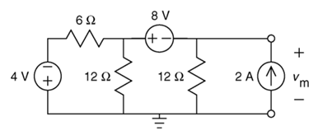 | CO1 | L6: Create | 5
Q5 | Discuss Step up, step down and isolation transformers with appropriate diagrams. | CO1 | L1: Remember | 5
Q6 | Discuss Thevenin’s Theorem with one example. | CO1 | L6: Remember | 5

